MEV
If target token 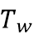 appears in sentence , let be the corresponding embedding. Let 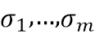 be the first singular values of the centered occurrence matrix. The MEV is the proportion of variance explained by the first principal component, calculated by (9.1)
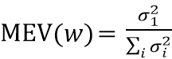
It ranges over 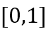. MEV measures how well a contextual embedding can be approximated by a static one. A high MEV indicates that the first principal component captures most of the variation in a word’s usage across contexts. Although models like BERT produce distinct embeddings for each occurrence, these embeddings vary primarily along a single dominant axis of meaning.

Self-Sim
The Self-Similarity is the average cosine similarity between embedding vectors, calculated using (9.2) below.
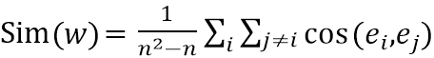
and ranges over . High self-similarity indicates that a word’s embeddings are constrained and similar across contexts, whereas low self-similarity indicates diverse usage.

Intra- and Inter-Group Similarity
Let 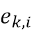 be the embedding assigned to cluster , with 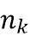 members, and let be the number of embeddings not in cluster . The Intra-Group Similarity measures similarity within clusters:
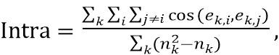
while the Inter-Group Similarity measures similarity across clusters:
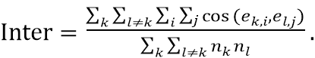
High Intra-Group Similarity indicates that embeddings within a cluster are contextually similar, whereas low Inter-Group Similarity indicates that clusters are well-separated.

